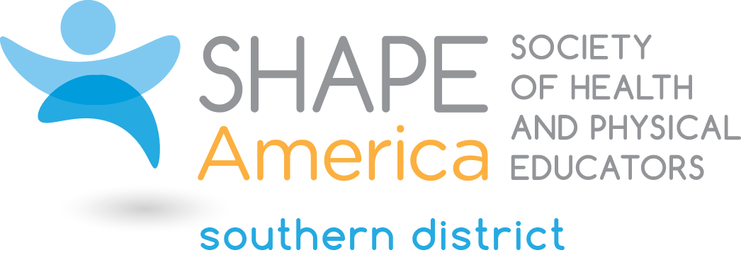
2019 Candidate for the Office of Member-at-Large

Ashley Grimes
Specialist PreK-12 Physical and Health Education
Pinellas County Schools
Parrish, Florida

Ashley is in her 12th year of education. She has her Bachelor’s degree in Physical Education and Health Teacher Certification from the University of North Carolina Wilmington and her Master’s Degree in Education Leadership from the American College of Education. Ashley began her teaching career at New Hanover County Schools in North Carolina. Then moved with her husband to Pinellas County, Florida where she taught Elementary and Middle School Health and Physical Education. From 2011 – 2017, Ashley coordinated and provided supports through various grants including the Communities Putting Prevention to Work Grant, Carol M. White PEP Grant and Foundation for a Healthy St. Petersburg Grant focusing on best practices in teaching health and physical education. Ashley is currently the Specialist for Pre K-12 Physical and Health Education for Pinellas County Schools in Largo, FL.

Ashley supervises and supports all Pre K-12 Health and Physical education teachers in 126 schools serving approximately 102,000 students. She provides supports through professional development opportunities, seeking funding and establishing partnerships and networking for her programs. Ashley has provided numerous presentations at the local, state and national levels. She is an OPEN National Trainer, Presidential Youth Fitness Program National Trainer, and Physical Activity Leader (PAL). In Pinellas County, Ashley oversees the Healthy Schools Program and has had over 30 schools reach America’s Healthiest School recognition.

Ashley has held multiple leadership roles in SHAPE Florida (formerly FAHPERDS) including serving as President, Vice President of the Physical Education division, and most recently appointed as convention co-coordinator for the SHAPE Florida Convention. In addition, Ashley has chaired a variety of ad-hoc committees including Membership Incentives and Website Re-Design. She has served as Elementary Council Chair for SHAPE America Southern District. In addition, Ashley has served as a reviewer for the SHAPE America Program Proposals.

What leadership qualities will you bring to the Southern District Leadership Council?
Through my experience as a health and physical education professional, I have acquired leadership qualities that I feel can contribute to continue to grow our Southern District. I am an advocate for our profession. I have advocated for funding through Title IV to fund quality health and physical education programs in our school district. I would like to provide our professionals with strategies to assess needs and create the ask for funds.

I am an innovative thinker. I like to think outside of the box. Within reason, I am not afraid to try new things. I also enjoy bouncing ideas with other professionals to help grow membership as well as grow the profession.

Lastly, I feel that I am passionate and hardworking. I strive to go above and beyond in everything that I do. When provided a task, I put my heart in soul into it and enjoy collaborating with others to achieve the overall goal and vision of the organization.

